MASTER AND DETAILS

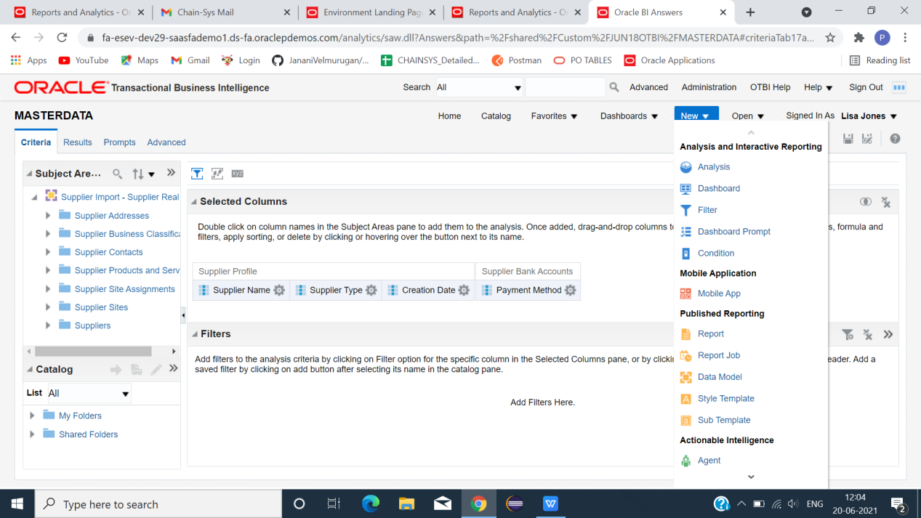

\*\*ANALYSIS - 1\*\*

\*CLICK NEW -> ANALYSIS -> CTRL+F(TO FIND OUR SUBJECT AREA)->SUPPLIER IMPORT-SUPPLIER REAL TIME(SUBJECT NAME).

\*SELECT COLUMN (AS WE NEED) -> SELECTED COLUMNS(COLUMNS WE SELECTED FOR OUR REPORT).

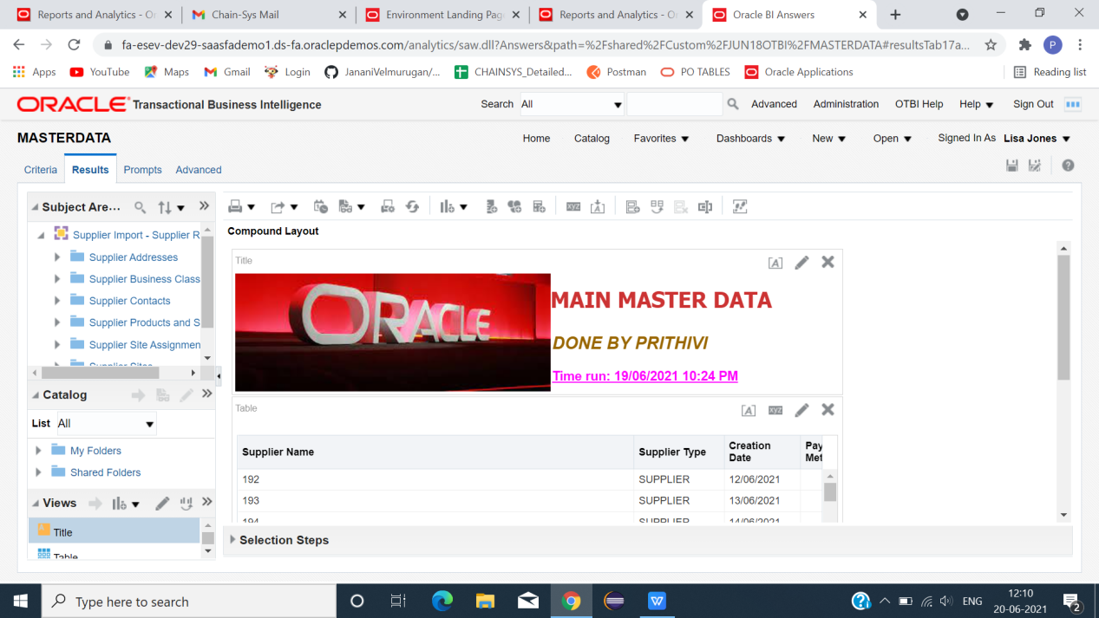

\*CLICK RESULT(TO VIEW OUR DATA AS WE SELECTED IN CRITERIA).

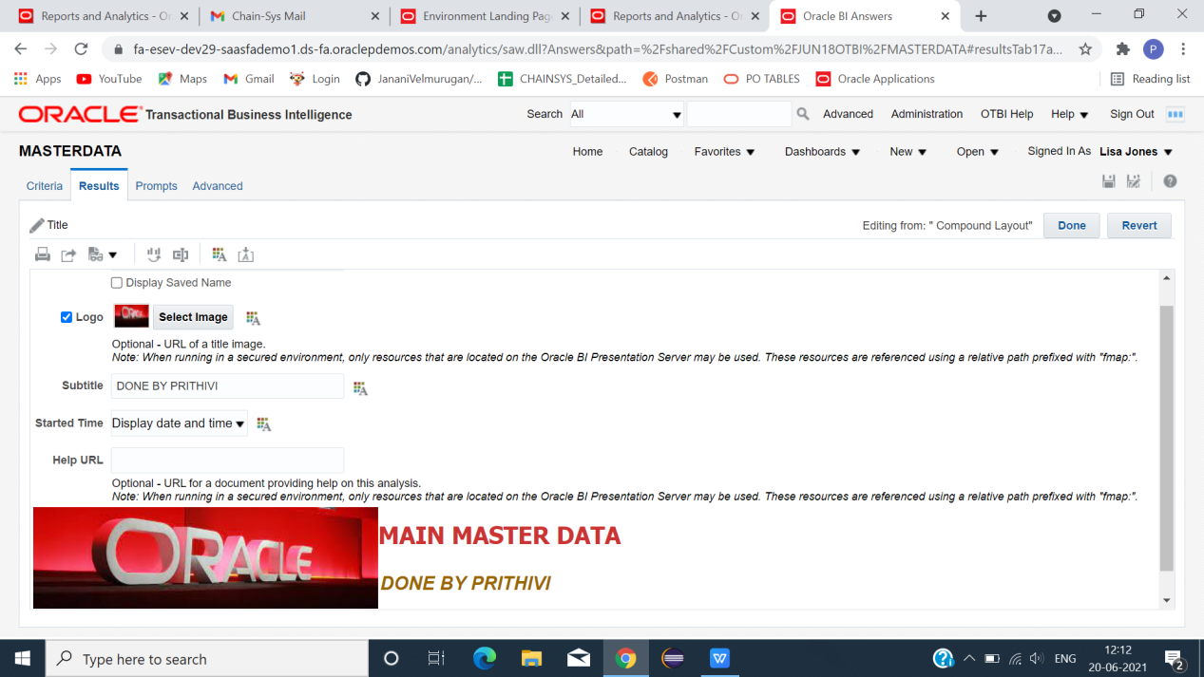

\*CLICK EDITVIEW(TO EDIT OUR TITLE CARD AS WE NEED).

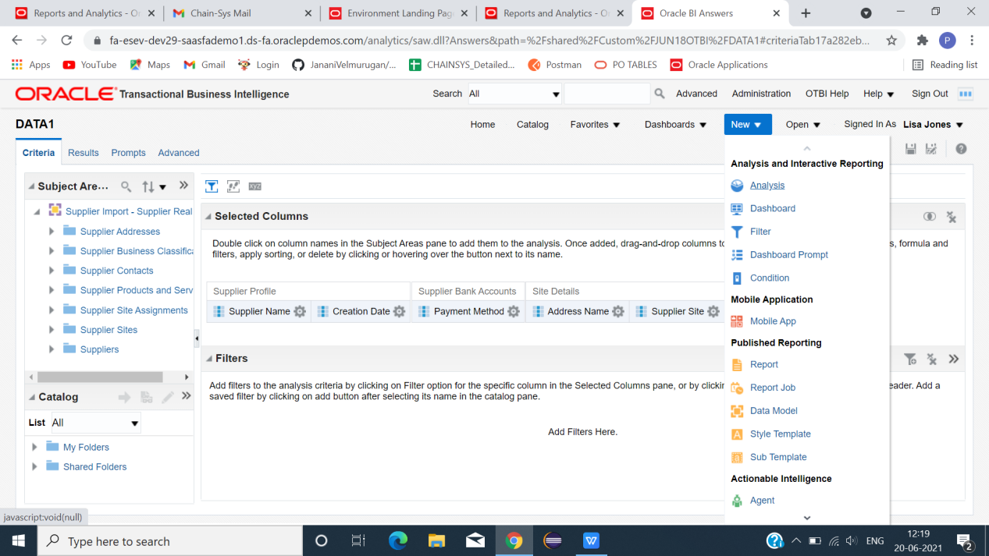

\*\*ANALYSIS 2\*\*

\*CLICK -> NEW -> ANALYSIS -> SELECT SUBJECT AREA -> SELECT COLUMNS.

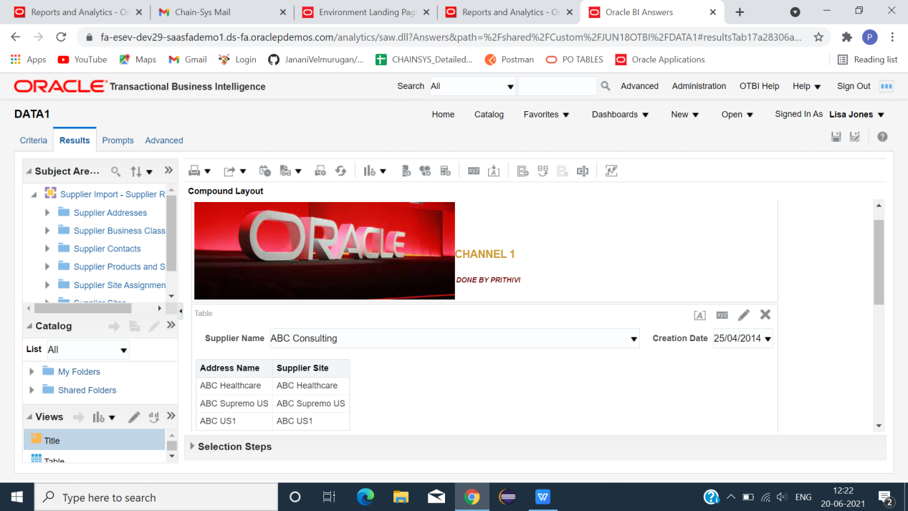\*CLICK RESULT(TO VIEW DATA).

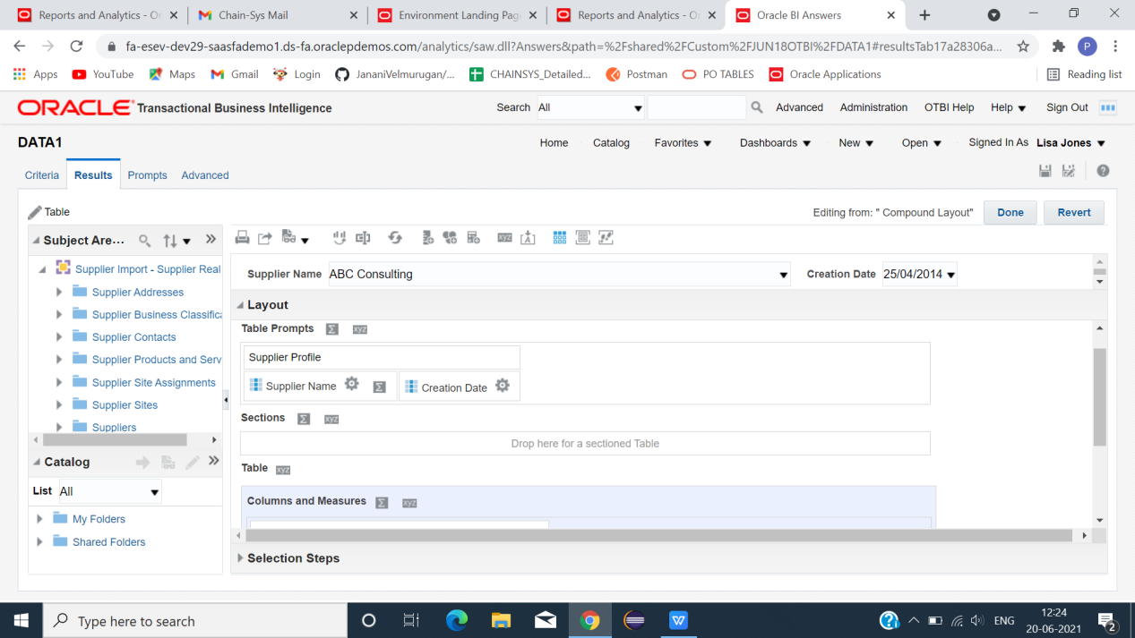

\*CLICK EDIT VIEW(TABLE CARD)-> CREATE TABLE PROMPT(IN MASTER ANALYSIS WHICH COLUMN WE HAVE CREATED MASTER LINK -> HERE THAT COLUMN MUST PROMPT(SUPPLIER NAME)).

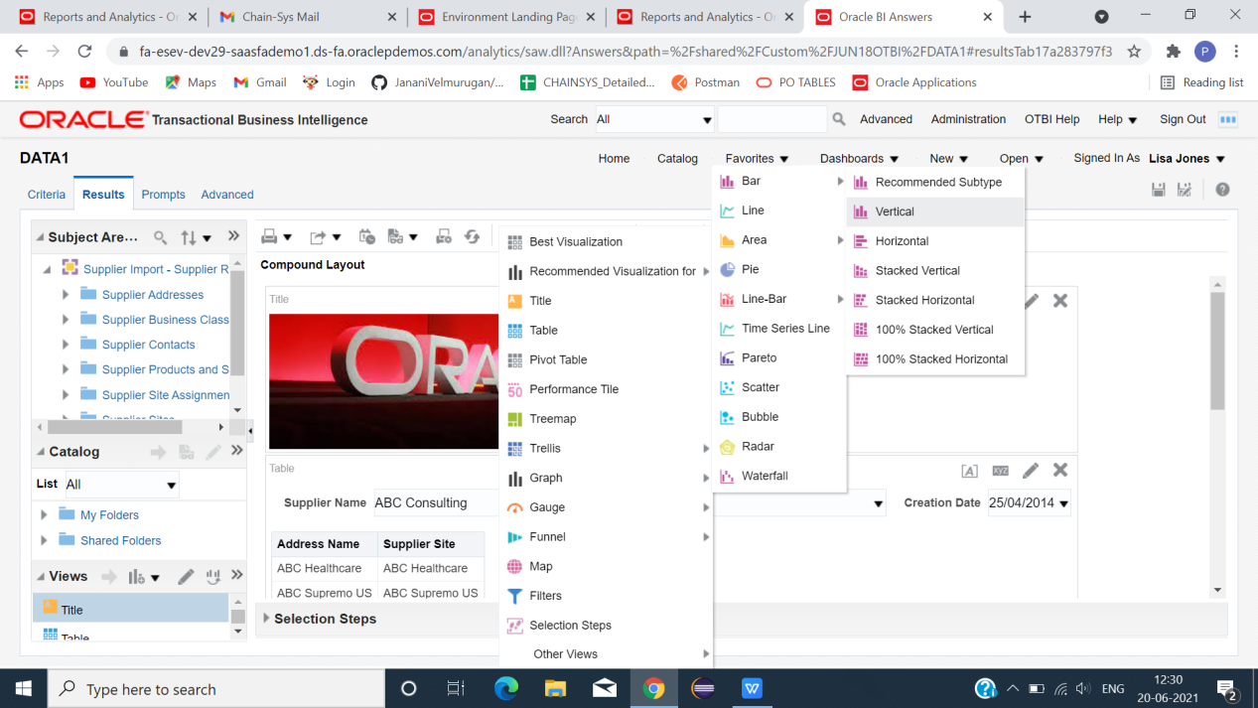

\*CLICK GRAPH ICON(TO MAKE GRAPH).

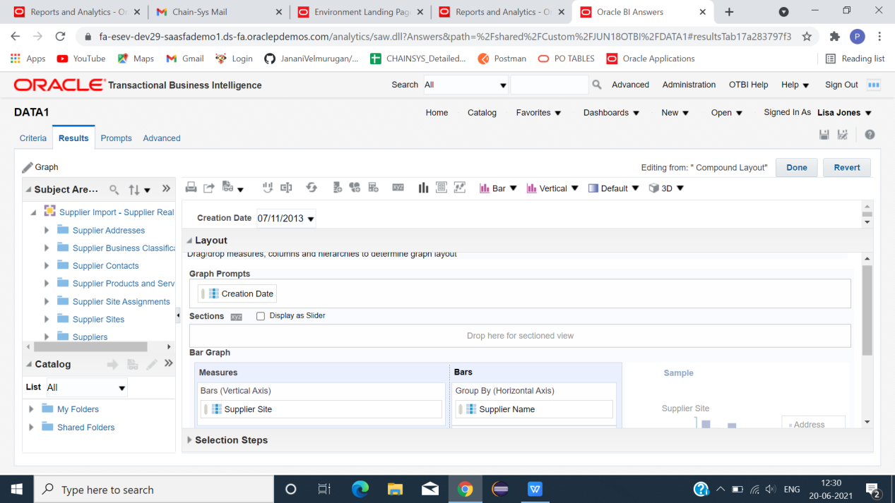

\*CLICK EDITVIEW(GRAPH SECTION)->GIVE (GRAOH PROMPT,VERTICAL AXIS,HORIZONTAL AXIS,GRP BY COLOUR)->(AS WE NEED TO DISPLAY IN OUR REPORT).

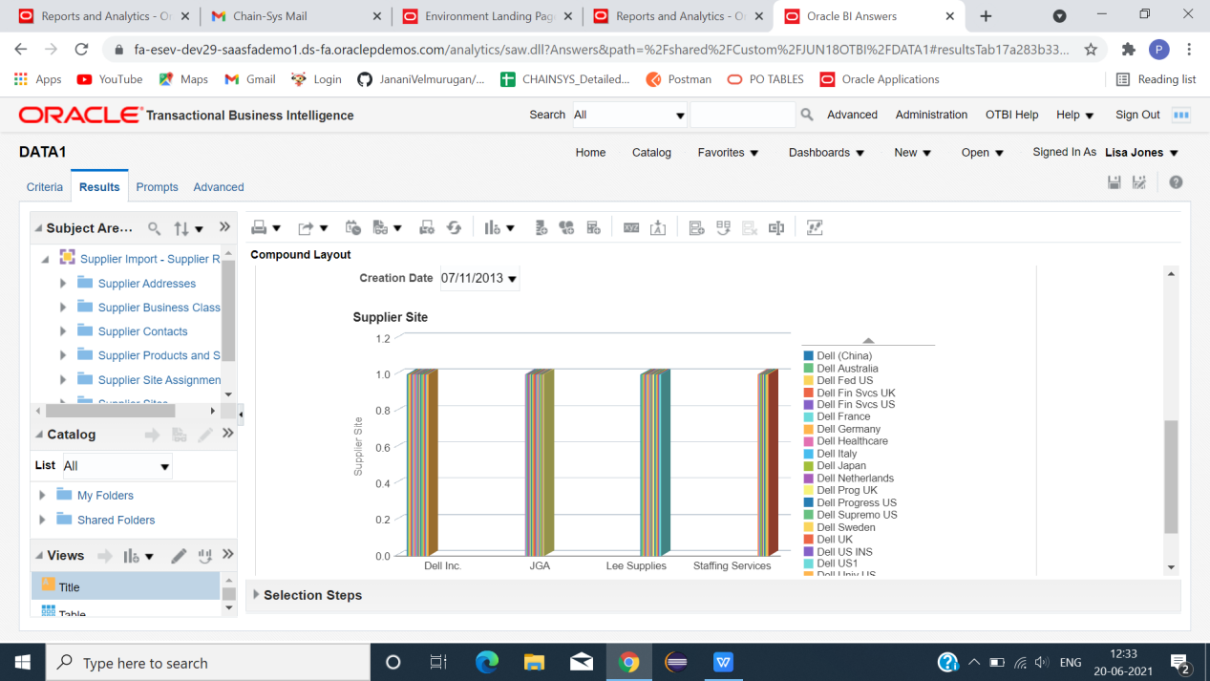

\*AFTER EDIT ( GRAPH ).

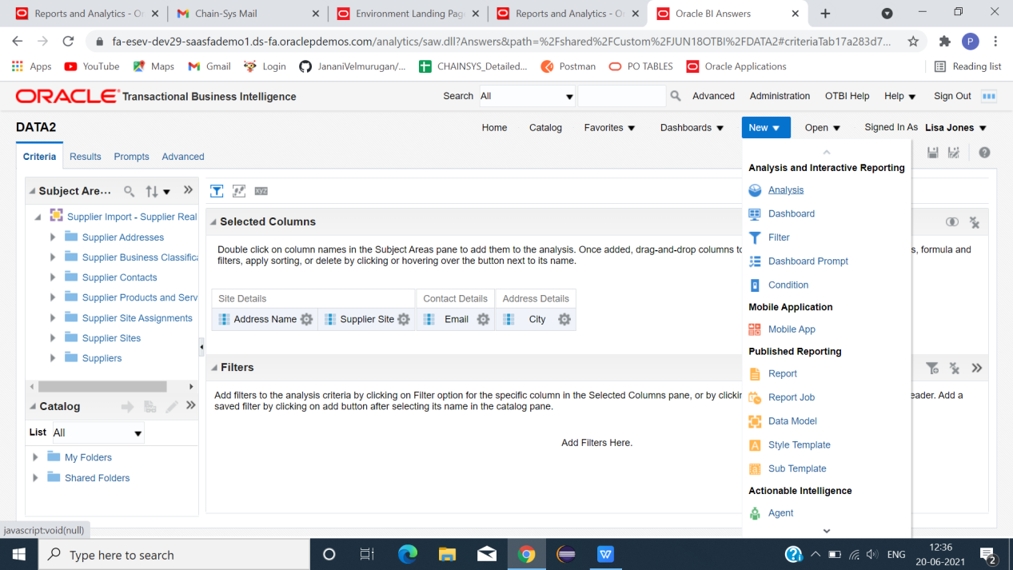

\*\* ANALYSIS 3\*\*

\*CREATE ANOTHER ANALYSIS -> CLICK -> VIEW -> SUBJECT AREA -> COLUMNS.

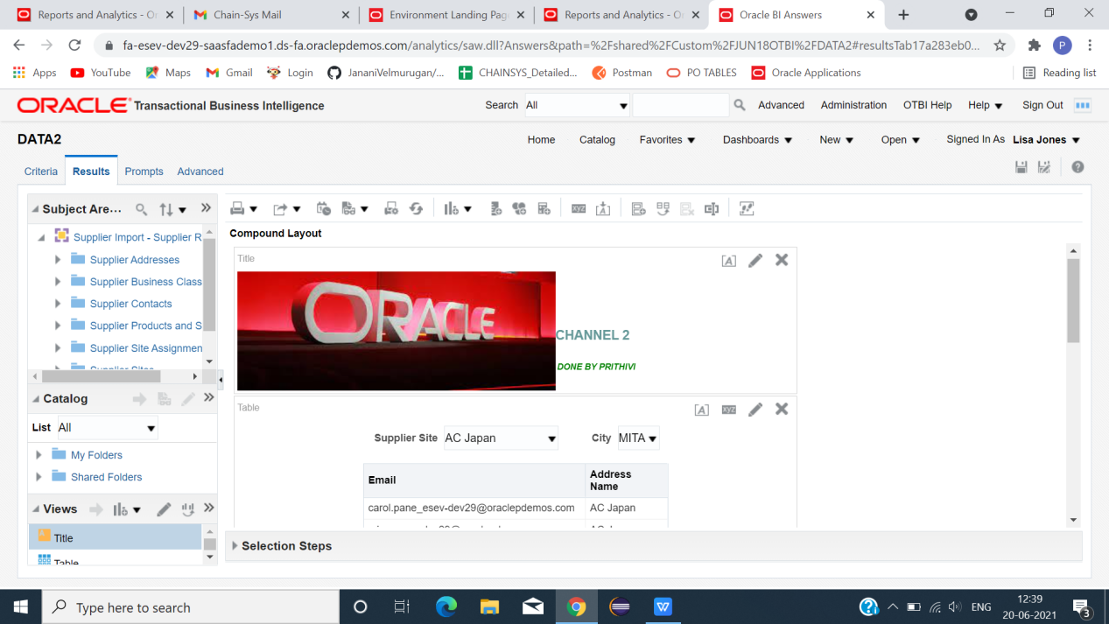

\*CLICK RESULT (CLICK EDIT VIEW(TO TITLE CARD)).

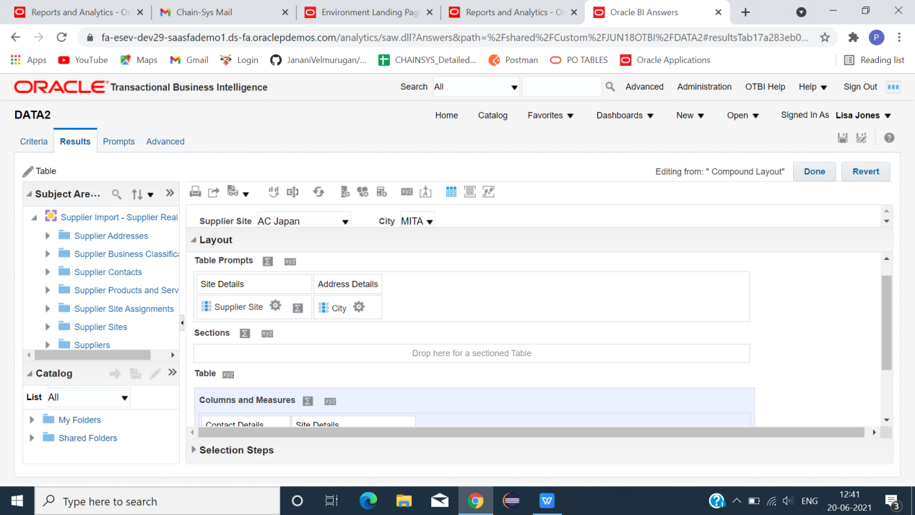

\*SELECT TABLE PROMPT (COLUMN SELECTED FOR MASTER LINK MUST PROMPTED HERE(SUPPLIER SITE)).

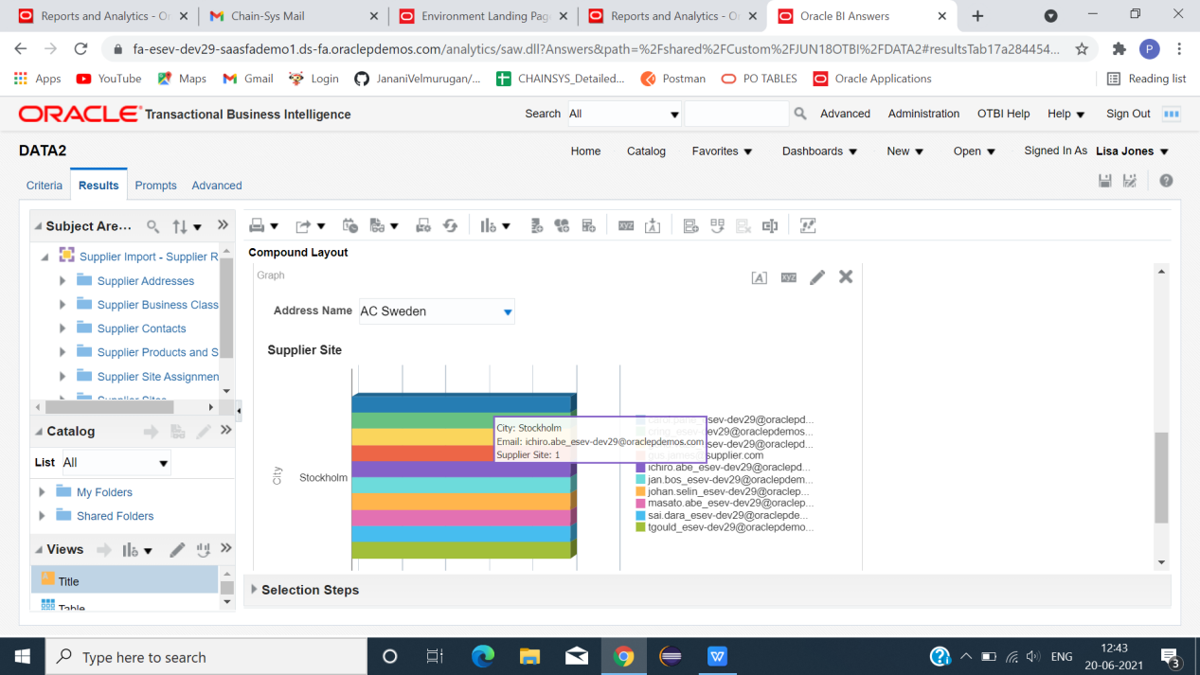

\*CLICK GRAPH -> EDIT VIEW (SELECT MEASURE AS WE NEED).

\*\*\*AFTER CREATING THREE ANALYSIS\*\*\*

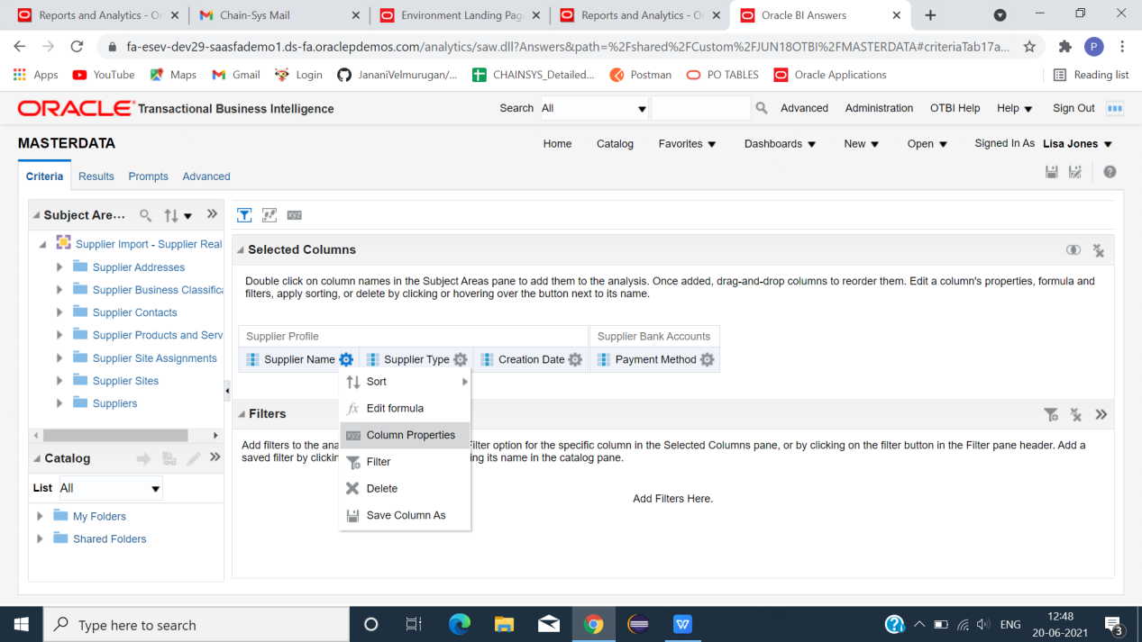

\*\*ANALYSIS 1\*\*

\*(CREATE MASTER LINK)->CLICK->SUPPLIER NAME->COLUMN PROPERTIES ->INTERACTION.

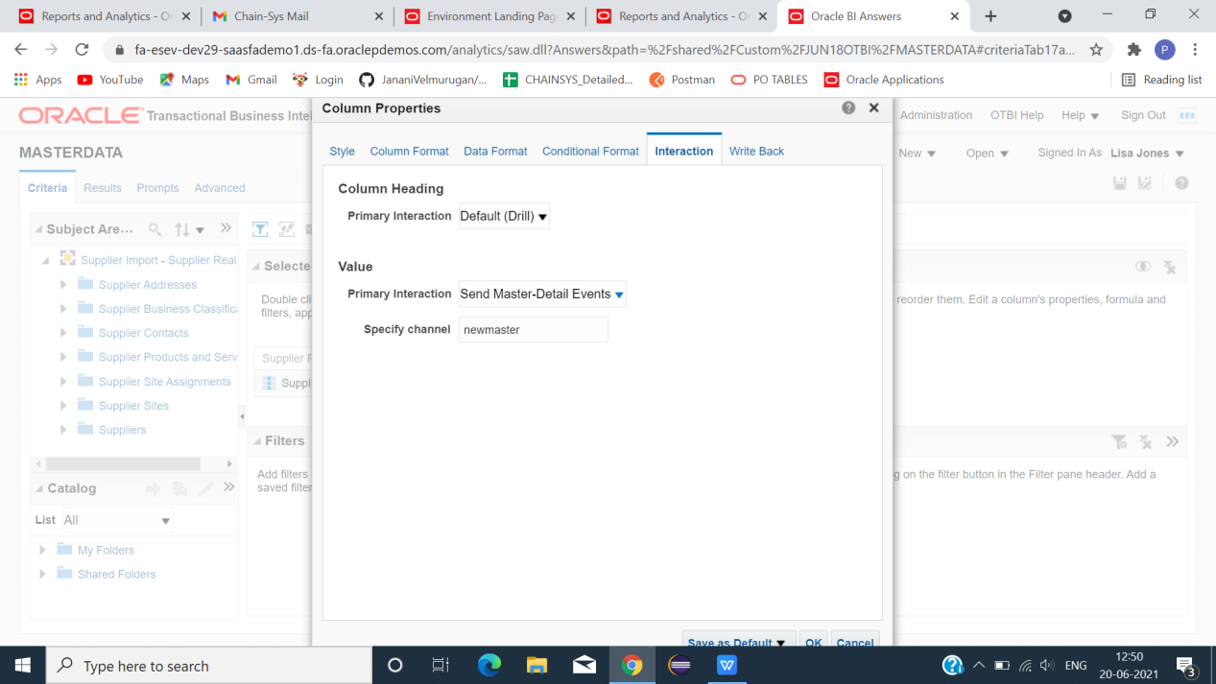

\*IN VALUE -> PRIMARY INTERACTION -> SELECT SEND MASTER-DETAIL EVENTS -> SPECIFY CHANNEL(NAME)->OK.

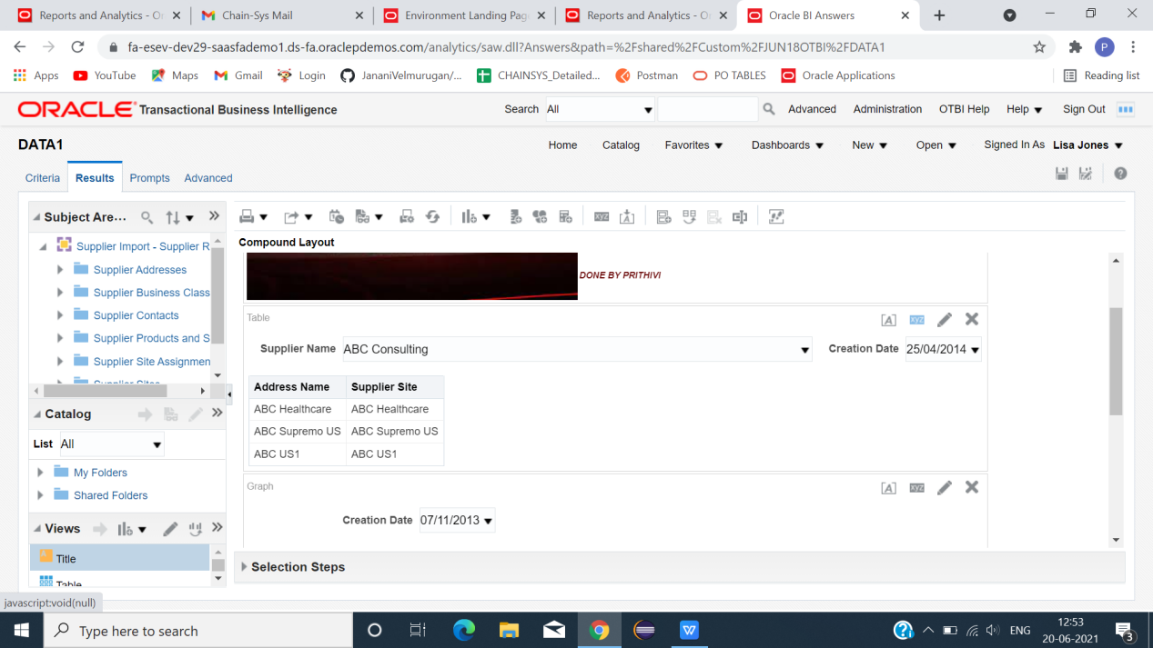

\*\*GO TO ANALYSIS 2\*\*

\*CLICK -> RESULT -> TABLE -> COLUMN PROPERTIES .

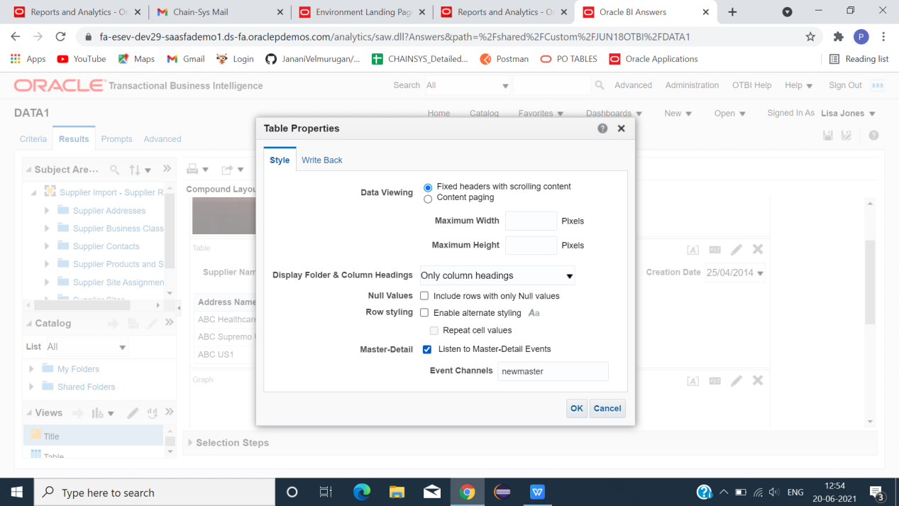

\*ENABLE MASTER-DETAIL->EVENT CHANNELS(MAP NAME CREATED IN ANALYSIS 1(MASTER))->OK.

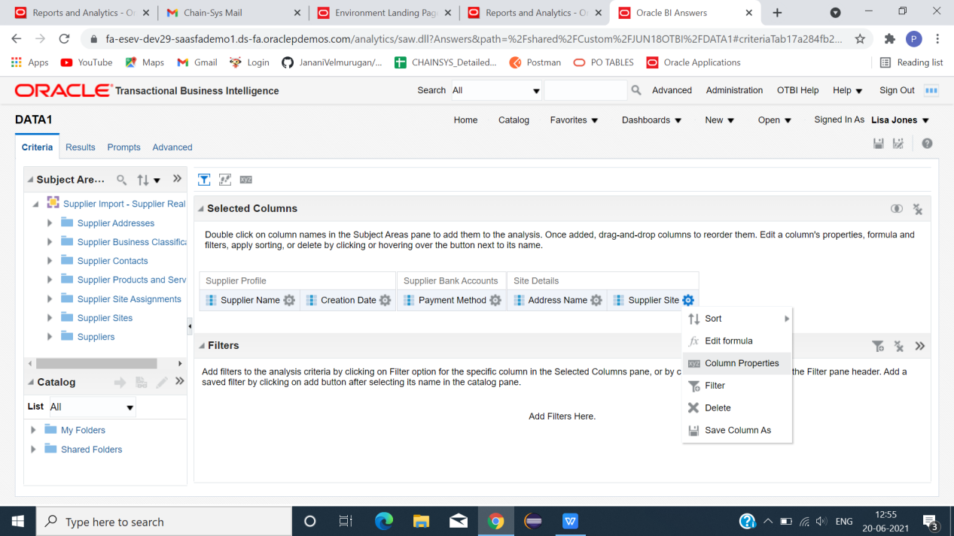

\*CLICK ->CRITERIA -> COLUMN PROPERTIES ->INTERACTION.

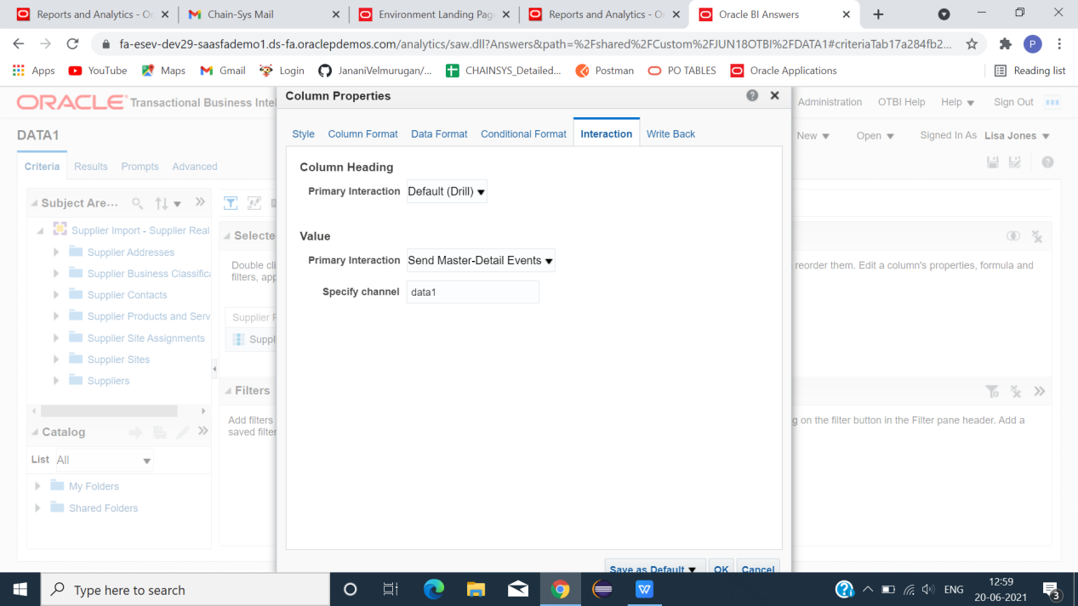

\*PRIMARY INTERACTION -> SEND MASTER-DETAILS EVENTS -> SPECIFY CHENNEL(NAME)).

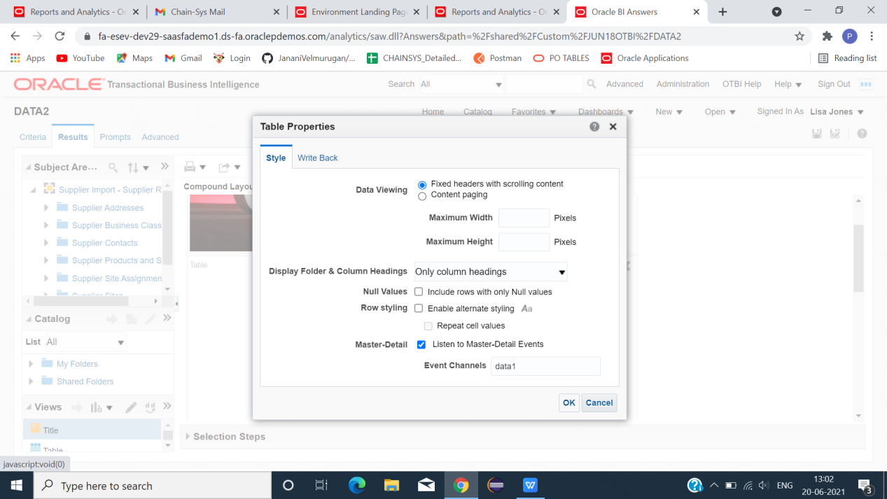\*\*GO TO ANALYSIS 3\*\*

\*CLICK -> RESULT -> TABLE -> COLUN PROPERTIES ->ENABLE -> MASTER-DETAIL -> EVENT CHANNELS(NAME IN ANALYSIS 2)-> OK.

\*\*IN BOTH ANALYSIS 2 AND 3)\*\*

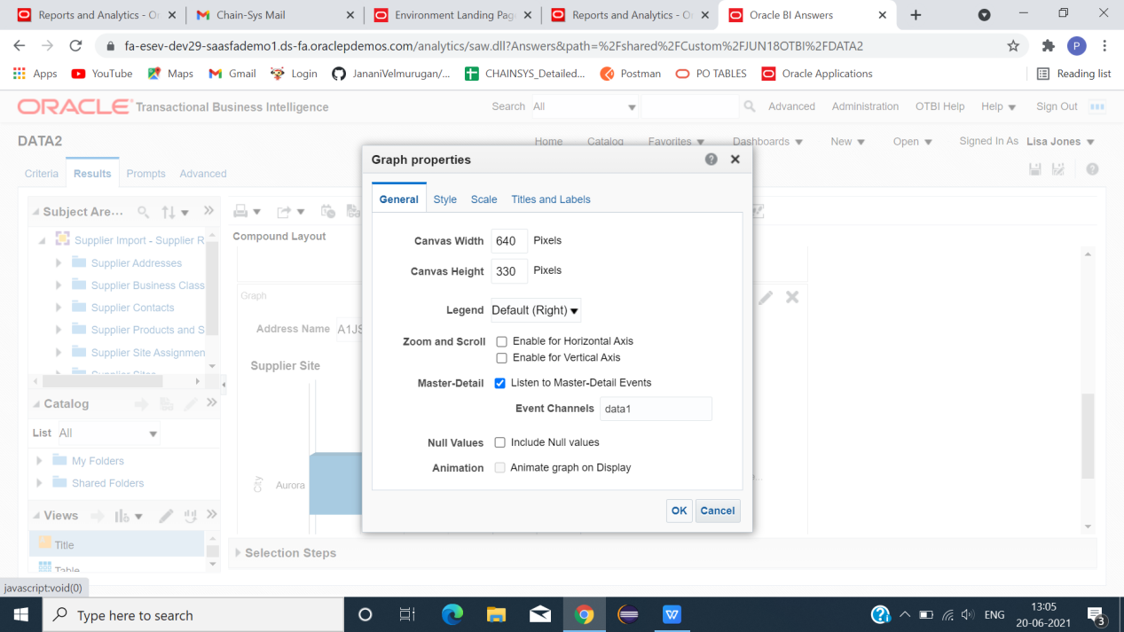

\*CLICK GRAPH -> COLUMN PROPERTIES -> ENABLE -> MASTER DETAIL -> EVENT CHANNELS(GIVE CORRESPONDING CHANNEL NAME)-> TO DISPLAY GRAPH CORRESPONDING TO THIER CHANGES IN TABLE.

\*\*CREATE DASHBOARD\*\*

\*CREATE NEW -> DASHBOARD -> DRAG COLUMN .

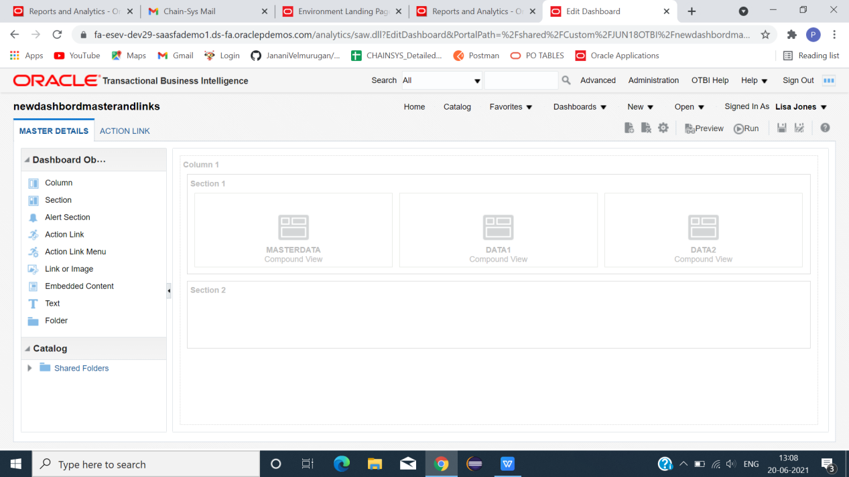

\*CLICK -> SHARED FOLDERS -> INSERT->ANALYSIS 1 , ANALYSIS 2, ANALYSIS 3 -> SAVE -> RUN.

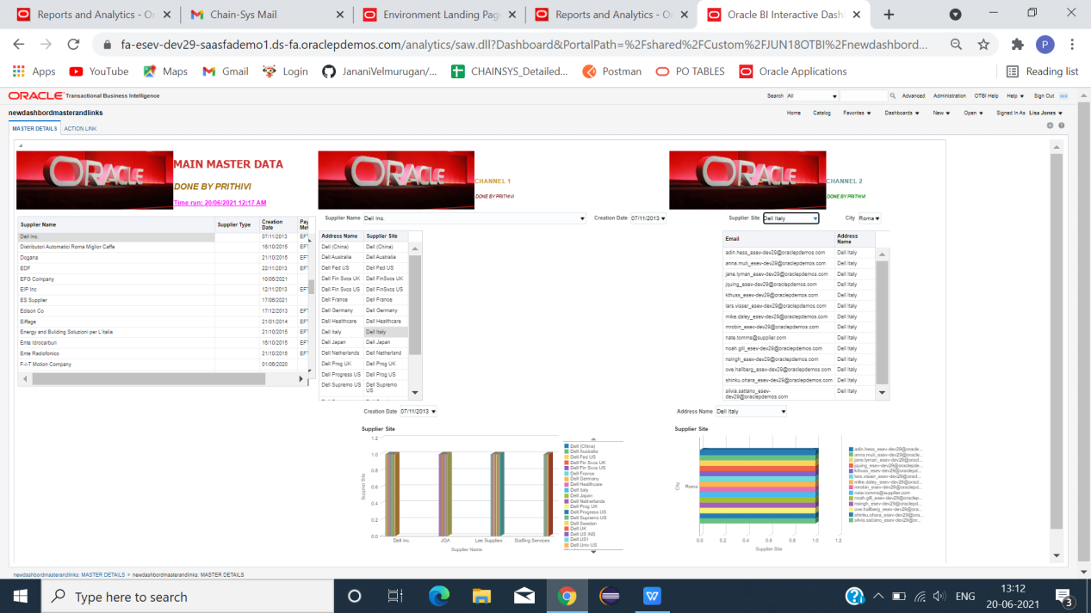

\*FINAL OUTPUT VIEW(MASTER AND DETAILS CREATED SUCCESSFULLY).